Winter Catalysis Workshop
Join in the exciting discussions and pushing forward the boundaries of chemistry and catalysis research for clean energy applications at the Winter Catalysis Workshop at University of Toronto. Featuring talks from catalysis experts Prof. José E. Herrera (Western University) and Prof. Steven Crossley (University of Oklahoma).
Date: December 11, 2018
Location: Wallberg Building Room 215
Host: Prof. Cathy Chin (Chemical Engineering and Applied Chemistry)
Schedule:
14:00-14:05 - Opening Remarks
14:05-14:50 - Conversion of renewable oxygenates to high value products over zeolites
and reducible oxides (Featured)
14:50-15:00 - Short Break
15:00-15:45 - Site requirements for vanadia anchored on titanium oxide: towards a
molecular level design of partial oxidation catalysts (Featured)
15:45-16:00 - Short Break
16:00-16:30 - Altering hydrodeoxygenation pathways via solvent tuning of reactive
hydrogen: an atomistic perspective
16:30-16:55 - Mechanistic consequences of hydrogen ligands on transition metal
clusters for hydrogenation of aromatic rings
16:55-17:00 - Concluding Remarks

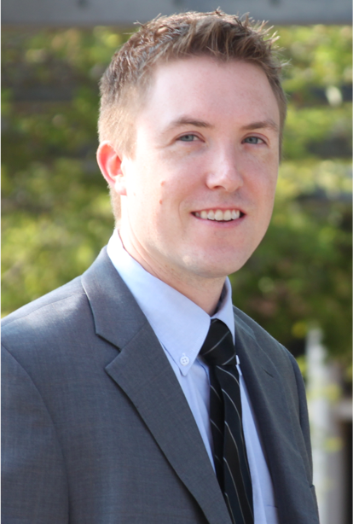
Prof. Steven Crossley
Conversion of renewable oxygenates to high value products over zeolites and reducible oxides
The thermochemical conversion of biomass to liquids through techniques such as pyrolysis and torrefaction is a promising approach to produce fuels and high value chemicals. The critical challenge lies in the subsequent catalytic upgrading. Biomass decomposition streams commonly contain a wide range of chemical compounds in a mixture that should be upgraded through very different types of chemistry to maximize the overall value of the product. Selectively coupling light C₂ and C₃ compounds to higher value products, for example, while selectively removing oxygen from larger phenolic and furanic species is necessary to avoid large losses of biomass derived products to either low value coke or light gases. Significant advances have been made in recent years to separate the biomass degradation products into streams rich in families of compounds such as light oxygenates, furanics, and phenolics. This separation enables targeted catalytic upgrading to yield specialty chemicals and fuels. Two families of catalysts that have shown considerable promise for the catalytic upgrading of these families of oxygenates are metals supported on reducible oxides and zeolites. In this contribution we will discuss the mechanism required for unique coupling reactions of light carboxylic acids with other renewable oxygenates over zeolites. Selective acylation reactions can occur under the high temperature and low pressure conditions necessary for coupling with pyrolysis and torrefaction processes. We further show how this reaction can be used to not only increase the carbon efficiency of a process, but also produce high value specialty chemicals.
The selective deoxygenation of oxygenates including furanics and lignin derived pheonlics present yet another significant challenge for the production of high value products from biomass. While metals supported on reducible oxides such as Pd or Ru/TiO₂ demonstrate considerable promise for these selective deoxygenation reactions, the nature of the active site required for these transformations is not well understood. We discuss a new approach that uses carbon nanotubes acting as hydrogen highways to segregate active sites that are caused by promoter effects from those resulting from direct contact between the metal and the support. We reveal that the promising activity can be attributed to various active sites for the different C-O cleavage reactions of interest.
Biography:
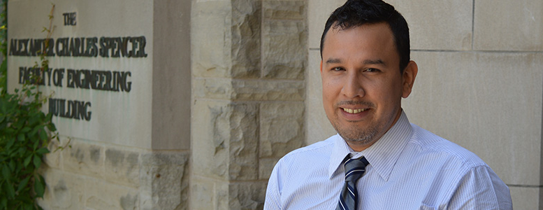
Steven Crossley received his Ph.D. in chemical engineering with Daniel Resasco from the University of Oklahoma in 2009. From 2009-2011, he conducted research at ConocoPhillips, now Phillips 66, in the areas of fluid catalytic cracking and hydrocracking. In August 2011, Dr. Crossley joined the University of Oklahoma as an assistant professor. His research focuses on reaction kinetics and nanomaterials synthesis. Most of his students’ projects involve kinetic fitting and evaluation of reaction mechanisms relevant to biomass conversion over zeolites or metals supported on reducible oxides. He is also a member of the Center for Interfacial Reaction Engineering, where his group studies heterogeneously catalyzed reactions in biphasic systems. Dr. Crossley is the recipient of the ACS PRF DNI award (2014) and the NSF CAREER award (2017). He has chaired and co-chaired numerous sessions in AIChE and ACS national meetings. He has published over 35 peer reviewed journal articles, including high impact journals such as Science, Nature Communications, and Energy and Environmental Science, and given over 40 oral presentations at national meetings and departmental seminars.
Prof. José Herrera
Site requirements for vanadia anchored on titanium oxide: towards a molecular level design of partial oxidation catalysts
Due to their bifunctional nature, metal oxide catalysts have been extensively investigated for aerobic and anaerobic oxidative dehydrogenation processes. In most cases, these metal oxides need to be anchored on a reducible metal oxide support and the active site carefully engineered to ensure successful catalytic performance. Our recent work in this area indicates that, for the case of vanadia anchored on titanium dioxide, a kinetic model that incorporates a catalyst reoxidation step, where molecular oxygen adsorbs into a titanium oxide support oxygen vacancy accurately predicts the kinetic parameters for the case of ethanol partial oxidation. This result opens a specific path to elucidate catalytic site requirements and a design strategy for the most active catalytic species. We have used this information to develop a strategy for metal oxide support design where the degree of available vanadia anchoring points on the titania support is careful grafted on the surface. This in turn results in in a very narrow distribution of extremely active and well dispersed vanadia catalytic species even at loadings above nominal monolayer coverage. A deeper insight into catalytic behavior of the active vanadia species was obtained by comparing intrinsic kinetic parameters for ethanol oxidative dehydrogenation. Results indicate that the reaction energetics is dependent on the number of vanadia anchoring points on the titania support and the resulting distribution of vanadia species, which validates our previous hypothesis of a strong link between the active vanadia species and lattice oxygen from the titania support during catalytic turnovers.
José E. Herrera is an Associate Professor of Chemical and Biochemical Engineering at Western University. His research efforts are focused on the description, prediction and modulation of surface phenomena at the nanoscale. His research methodology aims at establishing a sound model of the structure of the different species present in a material and its transformations under reaction conditions. This approach and his multidisciplinary expertise has enabled him to successfully address diverse challenges, ranging from the description of the changes in electronic structure of metal oxide active sites during catalytic oxidative dehydrogenation processes, to elucidation of the dissolution mechanisms of lead corrosion deposits in drinking water distribution systems.
José joined Western in 2007, after working as a Research Associate at Pacific Northwest National Laboratory for two years developing novel grafting techniques for metal oxide anchoring on different supports, previously he was granted a Fulbright Scholarship to obtain his PhD from the University of Oklahoma.

Yun D. Song Y. and Herrera J. E., Molecular Catalysis. 448: 122-134, 2018. Yun D. and Herrera J. E. ACS Catalysis 8:4681-4693, 2018. Yun D. and Herrera J E. Journal of Catalysis. 350: 72-85, 2017. Yun D., Song Y. and Herrera J. E. ChemCatChem. 9: 3655-3669, 2017.

